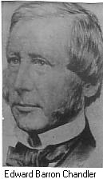

- born in August 22nd, 1800 at Amherst, Nova
- his father is sheriff of Cumberland County in Nova Scotia
- he is a lawyer, judge, politician and administrator
- he was married to Phoebe Milliage, and had 11 kids, only 7 lived
- he was elected to the legislative assembly for the County of Westmorland
- in 1844, he was elected to the executive council
- he was offered a seat in the senate but refused because he wants to remain in the provincial field
- he strongly dislike the power the central government has
- he wants a stronger union to defend against the U.S.
- he’s main interest is the railway
- in 1851, he and Joseph built a railway within their two provinces’ border
- Chandler was made to be the commissioner in charge of the railway in the confederation
- in 1876, the railway was completed
- Chandler succeeded Tilley as governor of New Brunswick in 1878
- he died at the age of 80 in February 6th, 1880 in Fredericton.

